**APPENDIX 1**

**JOB APPLICATION PORTAL**

PROJECT REPORT

***by***

**NAME OF THE CANDIDATE(S)**

(Section:K19HK)

(Roll Number: _05_)

KHUSHBOO SHAKYA

(Roll Number: _04_)

EKTA RAJ

(Roll Number: _03_)

TUMPI SHANKRITYA



**Department of Intelligent Systems**

**School of Computer Science Engineering**

**Lovely Professional University, Jalandhar**

**OCTOBER-2020**

**APPENDIX 2**

**Student Declaration**

This is to declare that this report has been written by us. No part the

report is copied from other sources. All information included from other

sources have been duly acknowledged. We aver that if any part of the

report is found to be copied, we shall take full responsibility for it.



<<Khushboo Shakya>>

<<Roll number: _05 >>



<<Ekta Raj>>

<<Roll number:_04>>



<<Tumpi Shankritya>>

<<Roll number:_05>>

Place: LOVELY PROFESSIONAL UNIVERSITY

**Date: 30-10-2020**

APPENDIX 3

TABLE OF CONTENTS

TITLE PAGE NO.

1. Acknowledgments 4
2. Abstract/Summary 5
3. Introduction 6
4. Review of Literature 7
5. Project Contribution 8

5.1Materials and Methods 8-16

5.2 Results 16

5.3Conclusions 17

ACKNOWLEDGEMENTS

First of all , We are grateful to our deemed institution Lovely Professional University for successfully providing us this opportunity to make this project as a part of our education program. We would specially thank our teacher and supervisor Dr. Moin Hasan Sir for providing his invaluable guidance,comments, and suggestions throughout the course of the project.

We are really fortunate that, we had this kind of association and supervision of our honourable teacher which acted as a dawn to every dusk. His exemplary guidance ,continuous encouragement, and careful monitoring throughout our project and in everyday class.

We would also take this opportunity to express a deep sense of gratitude towards the teamwork performed by us. Everyone played their part honestly and sincerely and so this project is a fruit of our continuous efforts and guidance of our elders.It was truly an amazing experience.

ABSTRACT

This project is made by using Python programming including Graphical User Interface and Structured Query Language. It is an online Job Application Portal System where users can apply for jobs as well as company members can post job for selective posts. This project facilitates both the options that is for login by users as well as usage by recruiters. On selecting the option of recruiter, it will then ask to register and then will redirect a page asking details of company name ,license number and further more requisites. It will also provide the recruiter with the options to select the required post to offer for job. Here the recruiter can select multiple options for creating job in respective categories. After successful login with company name and password the recruiter will be able to post a job. On the other side if a person wants to apply for a job then he/she can click on that particular option. They will be redirected to the other required pages in succession. Filling all the details correctly will lead to successful application of Job. Everything has been written in a very easy and eye-catching format to enable the users to understand better and make the best use of it. In this present time of Corona Virus Pandemic , when every other thing is running online, this Online Job Portal will help many people to achieve what they want. The purpose of this study is to develop an online job application portal where applicants an easily find jobs and recruiters can find suitable candidates for their respective job posts.

INTRODUCTION

Our project is to make a Job Application Portal for users to give them accessibility to apply online for jobs . This Project will also depict that how a company posts job for the users. It will give the both sided view of the professional work. We have focused on making it very convenient and highly useful for the users. This Online Job Application Portal has the feature to post multiple jobs at one time. Here, the recruiter has the facility where he/she has multiple check boxes showing different posts. All what is required is just one click and the job will be posted. Indeed, it is a techno world and people have advanced with technology but yet a lot of new learners are there who are struggling daily to deal with online systems. Keeping this in mind our Project carries with it many user friendly features ,even if a new user is trying to make use of this online job application portal, then everything is pre- written there and following those instructions the new users can successfully login there.The application is educed as much as possible to avoid errors while entering the data. This online Job Portal is made quite attractive for users and also useful in the same side. No formal knowledge is needed for the user to use this system. Thus, by this all it proves that it is user -friendly. Moreover, this system is deigned for the particular need of the company to carry out operations in a smooth and effective manner. Python programming along with Graphical User Interface (GUI) has been used to make this project. This report is an explanation to our work and how different modules are working in this project.

REVIEW OF LITERATURE

(including research gaps and Project objectives)

This project Job Application Portal is made under the guidance of our teacher and by basic application of what we studied in class. We had two months of time to research and accumulate thorough knowledge to make this project. We did attend all our classes to gain knowledge and guidance of our teacher so that we can apply it successfully in our project . We also devoted research time through self study in order to revive the content taught in the class. This time period played a very important role in understanding the topic of project and concepts to make it.

The objectives of this project are as follows:

* To provide the information about new jobs.
* To develop a system where job applicants and recruiters can communicate with each other.
* To serve as a package which can be used by agencies to improve the efficiency of business.
* By using this Job Application Portal, the admin can keep the job catalogue updated all the time.
* To Manage the information of employer.
* To develop a user-friendly job portal application interface.

**PROJECT CONTRIBUTION**

* Materials and Methods:

There are various modules in this project and efficient working of each and every module makes the good running of project.

**Module 1 : The introductory module**

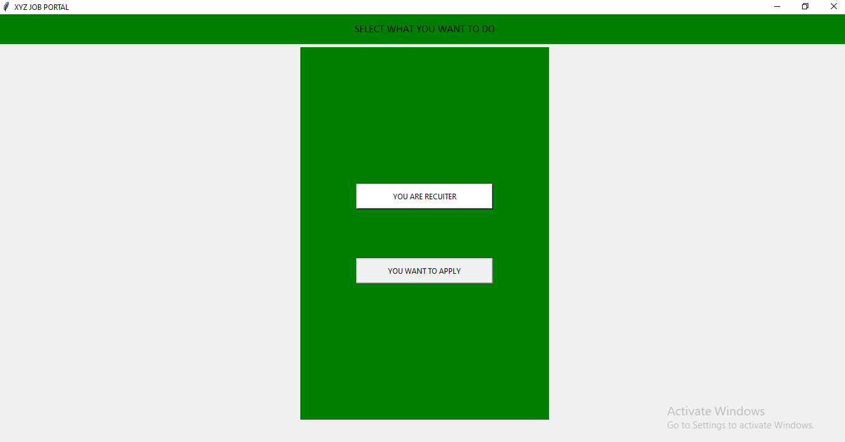

This is the first page of Job Application Portal . Here , this module provides the options to both recruiters as well as applicants. It also displays the message above to select what the user wants to do.

**Module 2:**

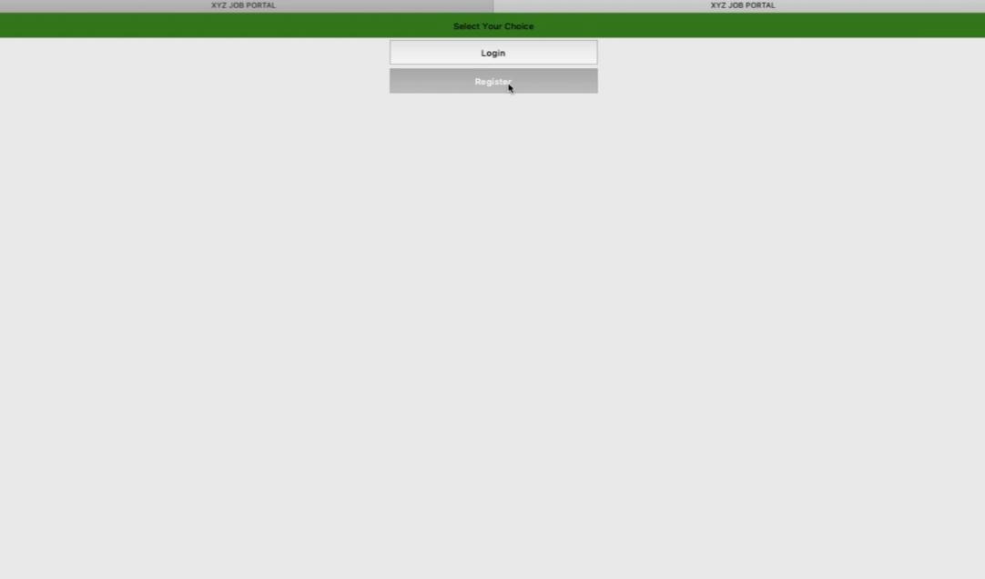

Module 2 redirects to the next page once the user wants to use this portal as recruiter. It is a very simple module.

**Module 3:**

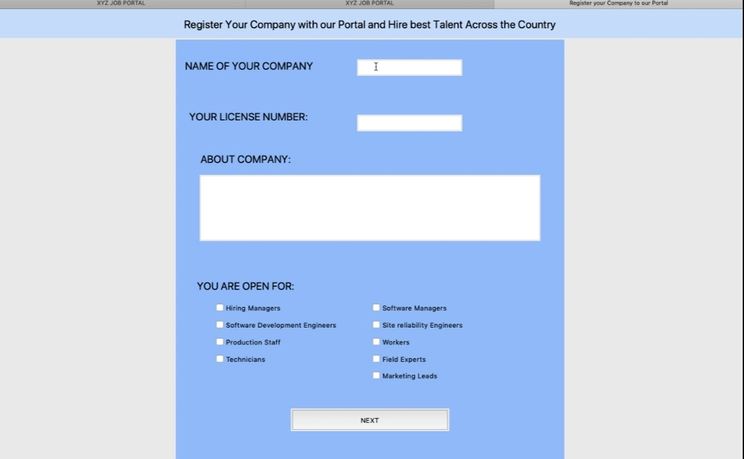

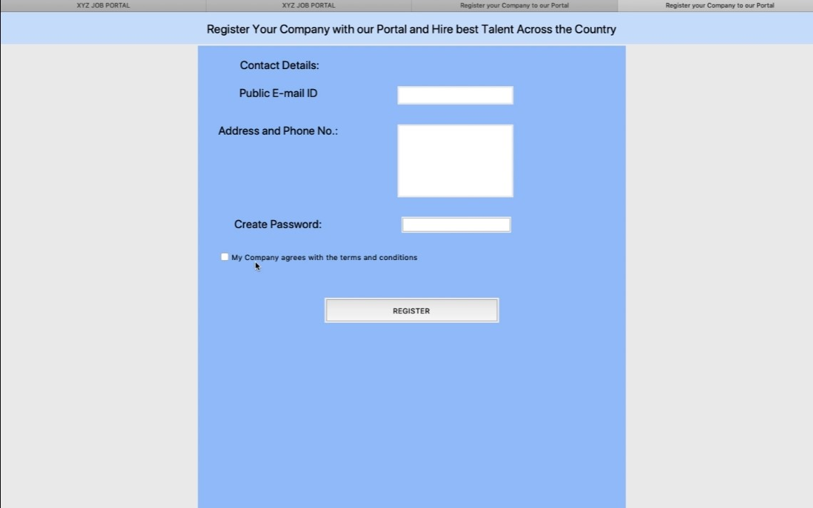

This module redirects to two pages in succession . Once the recruiter clicks on register option then he/she is allowed to register their company to our online portal.

This module asks all the important details regarding company to authenticate it properly for registering it. In the first part the user has to fill he name of the company ,the license number and details about the company. Next, it has many options with names of various posts written. The recruiter can select the desired check boxes for which their company wants to hire or has vacancy.

In the next section of this module, one needs to fill the personal information like contact details ,email-id,address and it will also give the option to generate a password which will be required later for login once the company is registered in the portal. After filling all these details ,the user needs to click on the check -box agreeing all the terms and conditions and then click on register. The company will be registered to this online Job Application Portal.

**Module 4:**

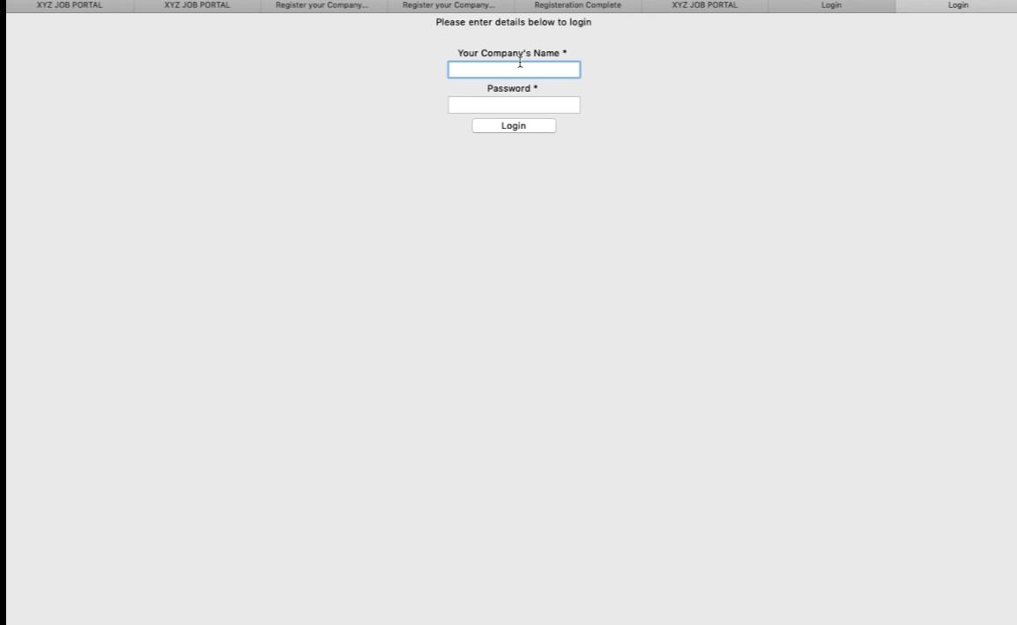

Module 4 carries forward the steps of module 3 . When the company is registered , the recruiter is redirected to login page again where the recruiter has to login with company name and password.

**Module 5:**

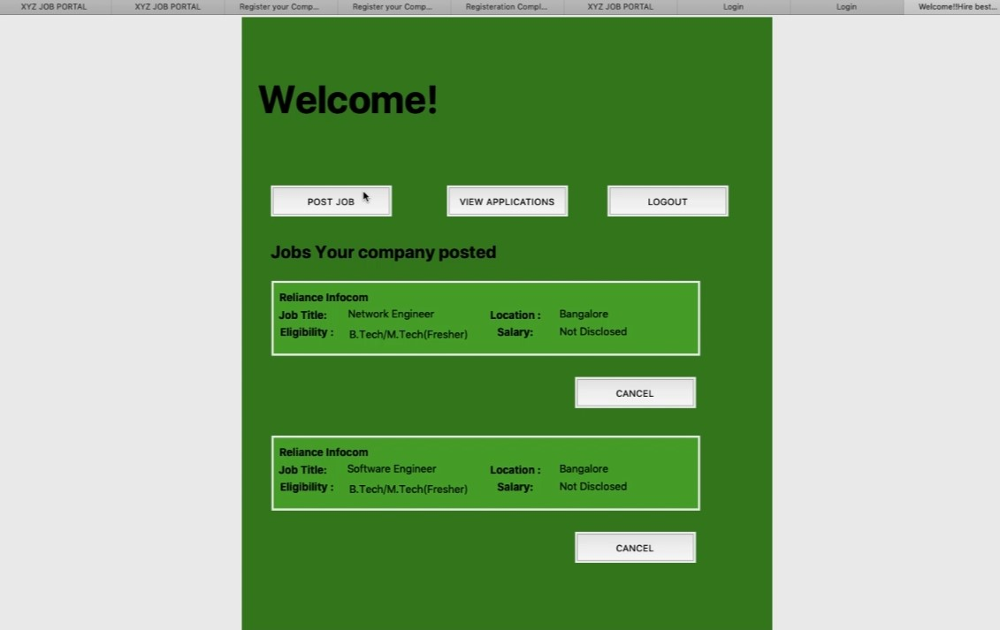

Once the recruiter has successfully logged in with company name and password ,this page will allow the recruiter to post job. It also gives the recruiter the rights to view the applications of applicants. Below are the information to see which job has been posted and eligibility required with it. The recruiter has right to cancel the job post,as per the requirements.

**Module 6:** 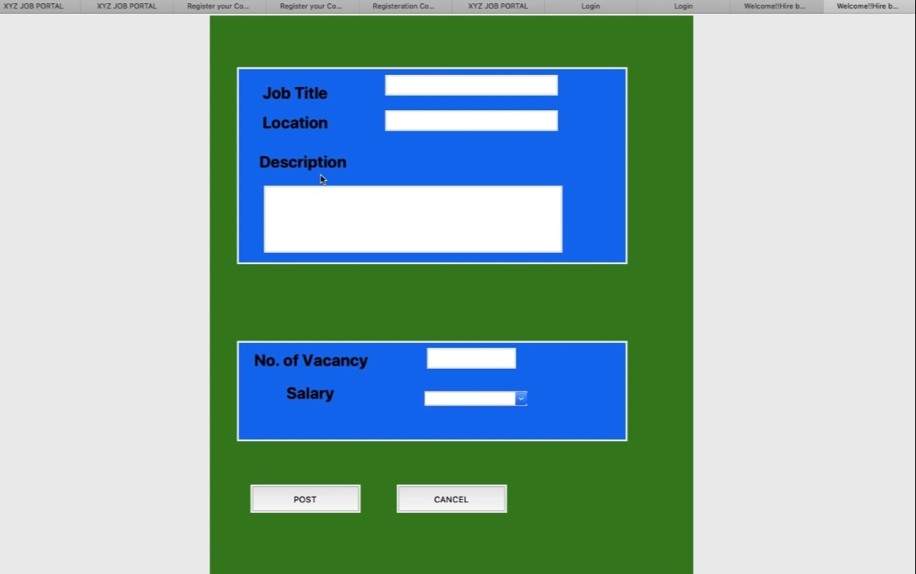

Thismodule allows the recruiter to fill the details regarding job and vacancy. After that on clicking on post option , the job will be posted and on clicking on cancel button, the recruiter will be redirected to previous page.

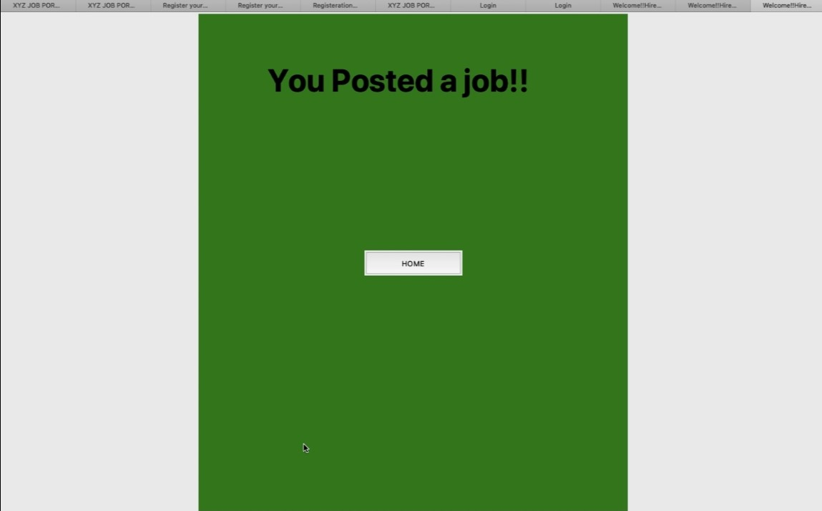Thismodule again has two sections and it allows the recruiter to fill the details regarding job and vacancy. After that on clicking on post option , the job will be posted and on clicking on cancel button, the recruiter will be redirected to previous page.

.

**Module 7:**

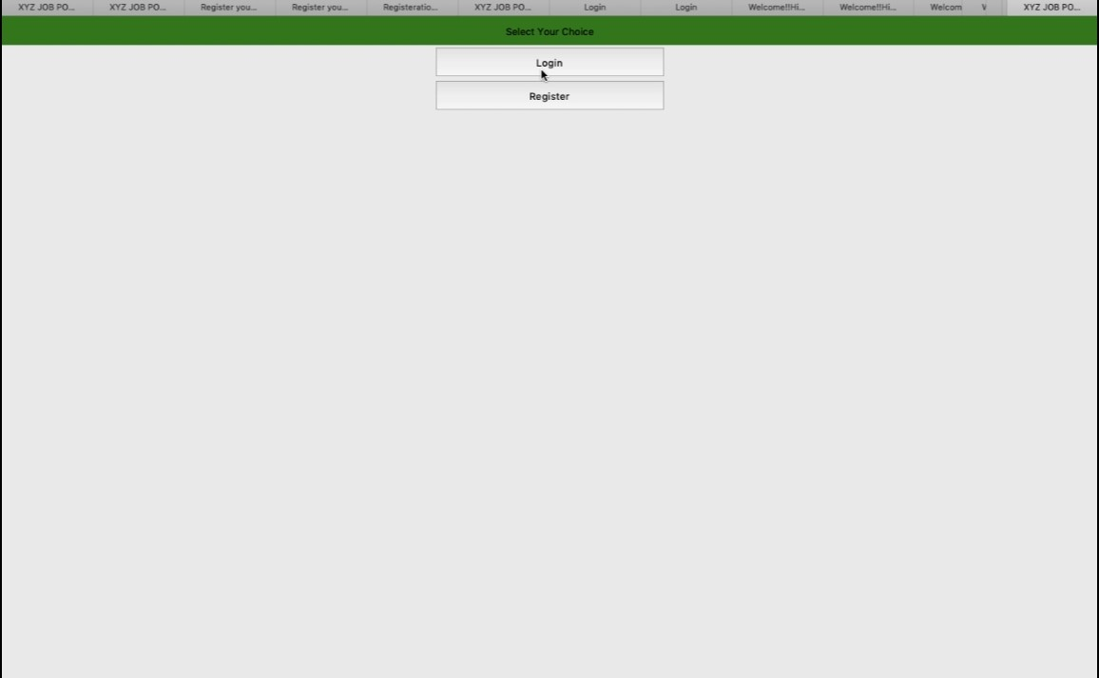

This module comes into use when the user is an applicant and not the recruiter. The user here clicks on “ **You want to apply**” as shown in the Module 1 and then redirected to this page as shown in the above module .After this he/she is required to click on register to get themselves registered first on our portal so that they can be hired by the best companies.

**Module 8:**

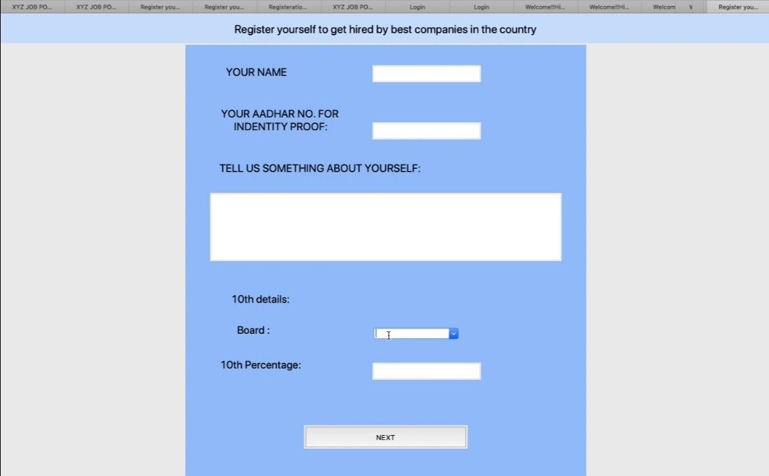

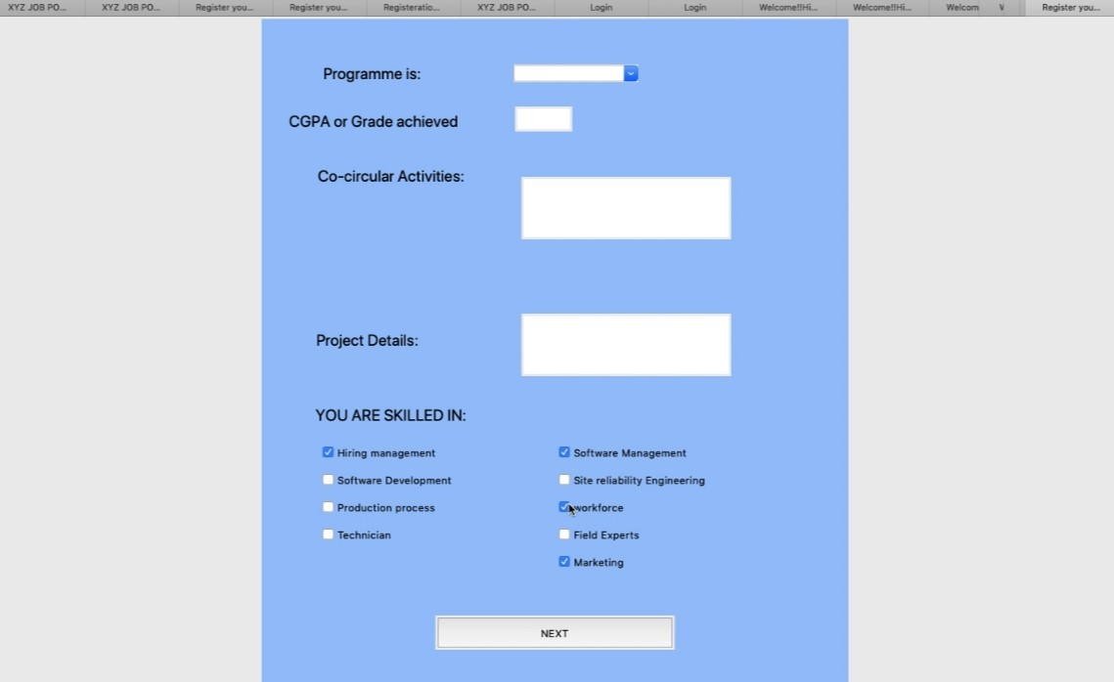This module comprises of two sections ,each section demanding the academic and some personal details of the applicant. By filling each of this details the applicant will be redirect to next page where they can generate their own password to secure their login. This Module also asks the applicants about their skills so as to refer them with best opportunities.

**Module 9:**

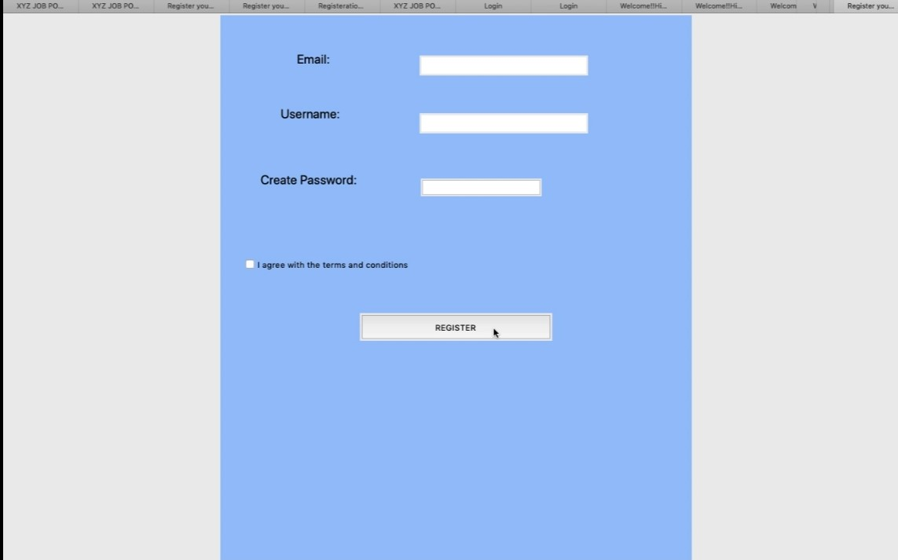This module carries forward the steps carried out in module 8. The applicant can create their required username and generate password for securing their login. Then the user has to click on the check box agreeing to the terms and conditions and then successfully register themselves to this Portal.

**Module10**:

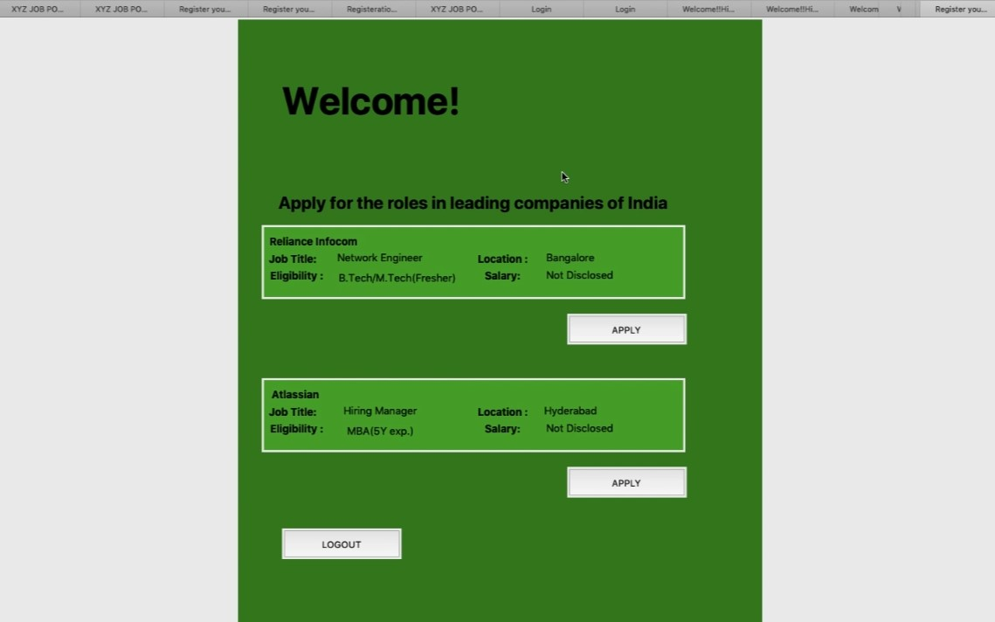This module gives information regarding the various vacancies available after the applicant has done login successfully. The applicants can apply for the job based on their capabilities and click on apply button.

**Module 11:**

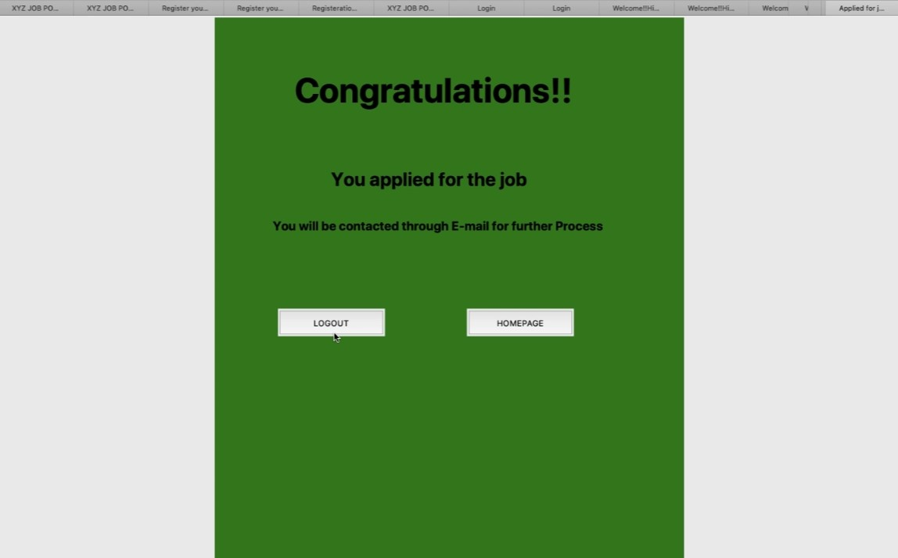

This module gives the message that the applicant has successfully applied for the desired job and he/she will be notified through email for further process.

* Now bringing light to the equal contributions, the first three modules and the major part of this report has been prepared by Tumpi, the next four modules has been prepared by Khushboo and the other four modules are prepared by Ekta . Each and every member has done their part and successfully contributed in the code as well as in report making.
* **Results:**

**1.Identification of need:** In the old manual system ,maintaining and retrieving the information was very tedious and lengthy . The records were never used to be in a systematic order but as a result of this online job application portal it has become very easy to maintain the records and reach to more people in less time and help the needy.

**2. Generates useful information:** This online Job Application Portal generates types of information which can be used for various purposes like to satisfy the user requirement , to be easy to understand by the user and operator and to have a good user interface.

**3.Economical Feasibility:** This online portal is very easy to access , all the hardware and software cost has to be taken up by the organization. And the benefits which the organization will receive from the proposed system will surely overcome the initial costs and later on running cost for system.

**4.Increased Awareness about the employment:** With the help of this online Job Portal a greater number of people has been blessed with employment opportunities. It has helped to increase awareness among large sections of people. Hence, it will do justice to the people with good merit and efforts.

* **Conclusions:**

After considering all the areas of this Online Job Application Portal, we can conclude that it facilitates quick and easy access to opportunities. It can also act as an important role player in increasing job opportunities and changing scenario of the business environment today has made more people to search for better career and recruiters to look for better potential. This Project enables users to enter the data through simple and interactive forms.From every part of the project the user is provided with the links through framing so that he/she can go from one option of the project to other as per the requirement . This is very simple and very friendly as per the user is concerned. Data storage and retrieval will become faster and easier to maintain because data is stored in a systematic manner and in a single database.It has also ensured easier and faster data transfer through latest technology associated with the computer and communication. Through these features it will increase the efficiency ,accuracy and transparency. Decision making process would be greatly enhanced because of faster processing of information since data collection from information available on computer takes much less time than manual system.Moreover , it is just the beginning as further the system may be utilized in various other types of operations.

`